***Active Passive Failover with Route53 Failover routing policy:***

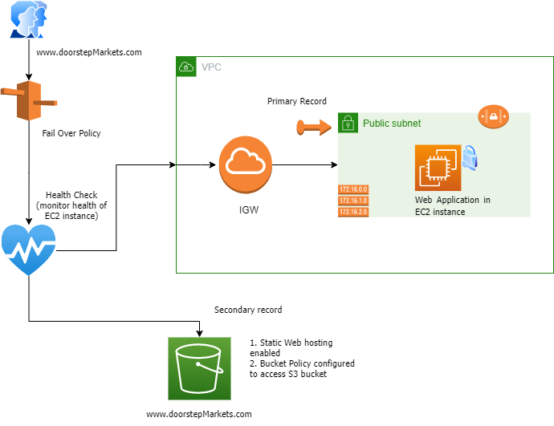

Above diagram illustrates active passive failover scenario using Route 53 failover routing policy

1. Created VPC with public subnet that host static web application in EC2 instance
2. Created Elastic IP and associated with EC2 instance
3. Configured security group and NACL to allow inbound traffic from internet
4. Configured route table to point internet bound in/out traffic to Internet gateway
5. Created Route53 health record which will monitor health of EC2 instance
6. Created route53 record with failover routing policy , to map [www.doorstepMarkets](http://www.doorstepmarkets).com (R53 domain) with EIP **as primary record.** Traffic **will always direct to static** web application hosted in EC2 instance after successful health check
7. If an EC2 instance is unhealthy, traffic will be directed to S3 bucket(same name as R53 record name → **secondary record in R53 failover routing policy**) that has Static Web Hosting feature enabled and also a bucket policy configured to access objects in that bucket.